Topic 3 Shifting Guidelines for Treatment Scientific Panel Lecturer: Dr Mark Kirchhof Community panelist : Marc Bourcier

Comments Regarding Key points for: Dermatology Trainees
- Dr. Bourcier commented that it was important for dermatology trainees to be familiar with assessment tools such as POEM, ESAI and SCORAD even if these are not used routinely in practice.
- Dr. Jack commented that there are more up to date guidelines than the 2013 guidelines presented, noting that were no systemics in 2013. Several participants agreed, with Dr. Asiniwasis commenting that they did not even have “Dupixent available then just the old immunosuppressants. A very exciting decade for all of us, unprecedented in AD.”
- Dr. Jack stated that currently the most up-to-date and “rigorous” guidelines are those of with NICE in the UK, as well as the European and German Guidelines.
- Dr. Asai asked if it was expected that dermatologists would have to use POEM clinically in the future to obtain coverage for medications, noting that dermatologists only use these assessments if they are forced to. Several participants commented that they hoped that assessments such as POEM would not become necessary to obtain coverage for medications.
- Dr. Asiniwasis questioned if anyone used POEM outside of clinical trials. Several participants responded that they did not.
- Dr. Jack remarked that, regarding POEM, for adult MS patients the DLQI often doesn’t capture the impact whereas the POEM severity strata are more “sensitive.”

- Dr. Asai questioned if it was fair to ask trainees to” learn another measurement tool that we don’t use.”
- Dr. Purdy stated that for trainees she thought that the DLQI and EASI were necessary, for exam and practical reasons. Dr. Asai responded that while they know that the DLQI is not good for AD, they use it regardless. Dr. Asiniwasis agreed that the DLQI was limited in some ways.
- Dr. Jack noted that it is the measure recommended internationally [in chat, not specified which measure, POEM or DLQI].
- Dr. Asai responded that they would not be using DLQI or EAS if they did not have to, but would
simply ask the patient “Is it affecting your life?”
- Dr. Jack disagreed, saying that it helps her to strategize how likely the patient is to want to pursue the systemic path of treatment.

Comments Regarding Key points for: General Practitioners
- Regarding the key point that GPs should review the 2020 JEADV Guidelines, Dr. Bourcier commented that they are simple and straightforward.
- Regarding the key point that GPs should be able to assess the severity of AD, Dr. Purdy remarked that she was not confident in their ability to do so as she gets many referrals for “rash” but conceded that this could be related to the fact that only half of her patients have access to primary care.
- Dr. Jack added that there is bias given that with the current state of healthcare, a physical exam, at least in Quebec, is beyond the scope for many GPs at the moment.
- Dr. Purdy commented that the role of the GP to add adjuvant therapies for sleep etc. may be of benefit but noted that GPs still use Benadryl extensively in her region.
- Dr. Joseph stated that while many GPs are great, they are overwhelmed when they see dermatological concerns and prescribe hydrocortisone for most dermatological concerns.

Comments Regarding Key points for: Adults and Adolescents
- Regarding the key point that patients should be careful when self-diagnosing or searching for information on the internet, Dr. Bourcier commented that there is a lot of misinformation available to patients.
- Regarding the point 5c, “Controlling the disease in early life may reduce the risks of acquiring other related conditions in later life (example: asthma, chronic rhinitis)”, Dr. Jack asked if there was any evidence to support this [unanswered].

Comments Regarding What Added Information is Needed
- Dr. Iannattone remarked that the old systemic therapies and phototherapy should be mentioned. Dr. Bourcier replied that they are mentioned in the guidelines and are touched upon in the lecture.
- Dr. Lynde asked if the lecture mentioned itch and sleep scores to which Dr. Bourcier replied that it did.

Comments Regarding Three Points Most Relevant to my Practice/Points Relevant to my Practice Not Found and/or Irrelevant info
  - No participant comments.

Key Takeaway: Vote Via Annotation

Slide | Results
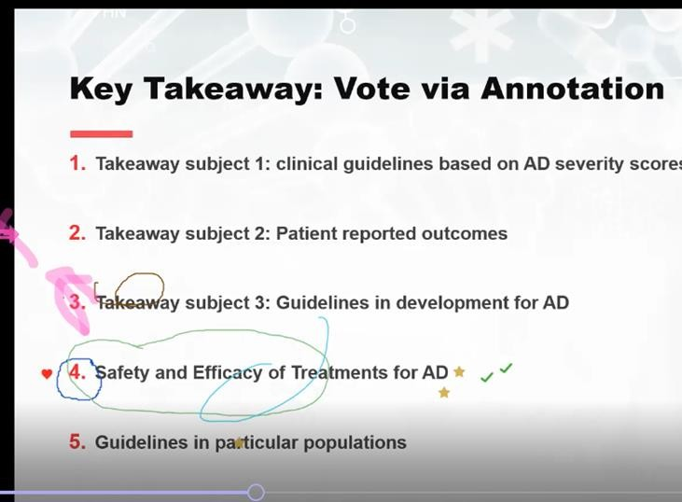 | - Safety and efficacy of treatments for AD-7 votes  - Guidelines in development for AD-2 votes

Overall Comments
- No further participant comments.

